

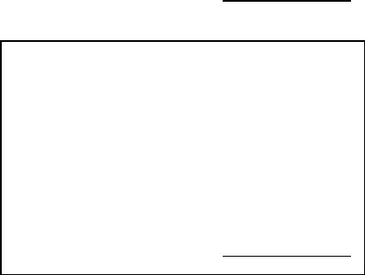

|  |  |  |  |
| --- | --- | --- | --- |
|  | K U P O N  PENGAMBILAN DAGING QURBAN 1438 H |  | K U P O N  PENGAMBILAN DAGING QURBAN 1438 H |
| D K M *……………………………..* |  | D K M *……………………………..* |
| N O | *:………..* | N O | *:………..* |
| N A M A | *:…………………………………….* | N A M A | *:…………………………………….* |
|  | PANITIA |  | PANITIA |
|  | (*…………………………..*) |  | (*…………………………..*) |
|  | Ttd/Paraf  K U P O N |  | Ttd/Paraf  K U P O N |
|  | PENGAMBILAN DAGING QURBAN 1438 H |  | PENGAMBILAN DAGING QURBAN 1438 H |
|  | D K M *……………………………..* |  | D K M *……………………………..* |
| N O | *:………..* | N O | *:………..* |
| N A M A | *:…………………………………….* | N A M A | *:…………………………………….* |
|  | PANITIA |  | PANITIA |
|  | (*…………………………..*) Ttd/Paraf |  | (*…………………………..*) Ttd/Paraf |
|  | K U P O N |  | K U P O N |
|  | PENGAMBILAN DAGING QURBAN 1438 H |  | PENGAMBILAN DAGING QURBAN 1438 H |
|  | D K M *……………………………..* |  | D K M *……………………………..* |
| N O | *:………..* | N O | *:………..* |
| N A M A | *:…………………………………….* | N A M A | *:…………………………………….* |
|  | PANITIA |  | PANITIA |
|  | (*…………………………..*) Ttd/Paraf |  | (*…………………………..*) Ttd/Paraf |
|  | K U P O N |  | K U P O N |
|  | PENGAMBILAN DAGING QURBAN 1438 H |  | PENGAMBILAN DAGING QURBAN 1438 H |
|  | D K M *……………………………..* |  | D K M *……………………………..* |
| N O | *:………..* | N O | *:………..* |
| N A M A | *:…………………………………….* | N A M A | *:…………………………………….* |
|  | PANITIA |  | PANITIA |
|  | (*…………………………..*) Ttd/Paraf |  | (*…………………………..*) Ttd/Paraf |